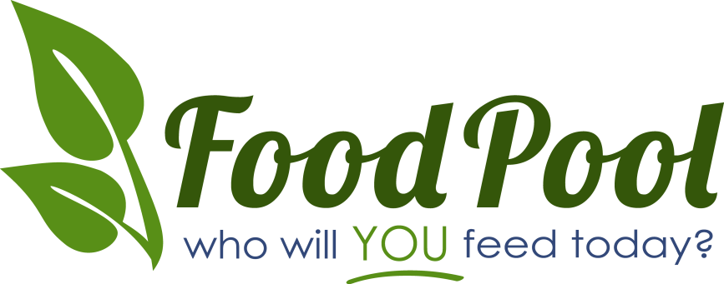

I don't know how to solve the world's problems, but I had some extra zucchini and I thought "maybe I can feed some people."

Our backyards are full of home gardens and fruit trees, many of which bear more produce than the gardener can consume. Often people end up with piles of unwanted zucchini, apples falling off trees to rot on the ground, peas that grow old and hard before they can be, and other beautiful produce that goes to waste.
At FoodPool, we see the "problem" of excess garden abundance as an opportunity! It is an opportunity to help provide those in need with fresh, ripe, homegrown produce. The only obstacle lies in linking home growers with their hungry neighbors. Our answer is FoodPooling.
Our mission is to create small, local groups that gather excess garden produce and deliver it to food pantries. These food pantries then distribute these fruits and vegetables to people who really need it. FoodPools are modeled on carpools - neighborhood based, easy to set up, and a big win for everyone involved. By creating FoodPools, we feed our neighbors while strengthening our communities.
FoodPool makes it easy to feed hungry people right near you. Please let us help you help people in YOUR neighborhood.

Please visit http://www.FoodPool.org to learn more about how you can help!

